PRACTICE PAPER
Y9 SPANISH
END OF YEAR
- Reading examples
- Listening examples with link to audios
- Writing examples
- Answers attached
Time allowed
72
Maximum marks
72
READING
Changes in Medellín
1 Read this comment about Medellín by a local broadcaster.
Antes, Medellín era una ciudad muy sucia, y la gente no reciclaba la basura. También había mucha violencia y drogas en las calles. La ciudad ha cambiado mucho.
Ahora Medellín es un sitio bonito con más zonas verdes y es menos industrial. Las calles están más limpias, también son seguras, y con mejor transporte público. La ciudad es tranquila y ha mejorado mucho.
Which statements are correct? Put a cross next to each one of the three correct statements. (3 marks)
A There were drugs on the streets.
B Medellín is more dangerous now.
C The streets were cleaner before.
D Medellín has more green spaces.
E There are more drugs on the streets.
F The city is now calm.
An unforgettable day
2 Read David’s diary entry about a day out.
David
El fin de semana pasado, mis amigos del colegio y yo fuimos al centro comercial. Me encanta ir de compras cuando tengo tiempo libre y si tengo dinero, me gusta comprar libros nuevos.
Cuando estoy en casa, veo películas en mi ordenador portátil, pero la imagen no es muy buena. Por eso, disfruté la película que vimos en el cine después de salir a comer.
*por eso – therefore
Put a cross next to each one of the three correct statements.
David says that… (3 marks)
A he went to school last week.
B he met his friends at the shopping centre.
C he enjoys going shopping.
D he bought new books.
E he watched a film at home.
F he went to the cinema.
My life online
3 Read what these people say about social media.
Alba: Mi pasatiempo favorito es chatear con mis amigos en línea. Normalmente uso mi tableta, pero en marzo voy a comprar un móvil nuevo.
Malek: Me gusta jugar a juegos en línea en mi móvil, y mi juego favorito es de terror. Me hace muy feliz porque es divertido.
Miguel: Soy aficionado a la moda. Me gusta publicar fotos en las redes sociales. Siempre uso mi portátil.
Who says what? Choose the correct answers. Put a cross in the correct column for each question.
(6 marks)
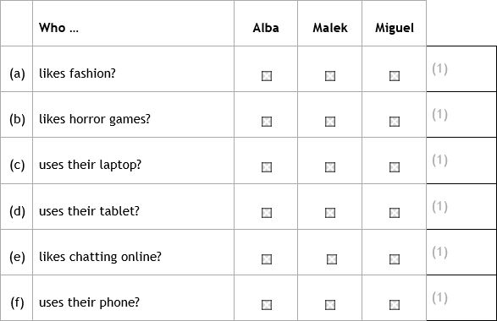
LISTENING
Descriptions
4 Mario is describing himself. What does he say? Complete the gap in each sentence using a word from the box below. There are more words than gaps. Click here: question4.mp3
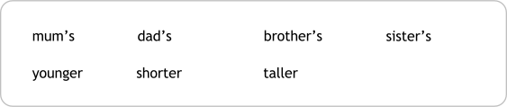
(3 marks)
a Mario's hair is different from his .
b Mario's eyes are like his .
c Mario's brother is .
DICTATION
5 You are going to hear someone talking about music. Sentences 1, 2 and 3: Write down the missing words in the gaps provided. In each gap, you will write one word in Spanish. (10 marks) Click here: question5.mp3
Example:
Me encanta bailar mucho.
1. Soy de la local.
2. Mi es la .
3. Mi toca el .

Sentences 4, 5 and 6: Write down the full sentences that you hear in the spaces provided, in Spanish.
Example:
Me gusta todo tipo de música.
4.

5.

6.

My favourite TV series
6 Manuel is talking about his favourite TV series. What does he say? Listen to the recording and complete the sentences by putting a cross in the correct box for each question. Click here: question6.mp3
a The series is about …
A police officers.
B young people.
C doctors.
(1 mark)
b It is on TV on …
A Mondays.
B Wednesdays.
C Fridays.
(1 mark)
c There is a lot of …
A violence.
B music.
C action.
(1 mark)
d Manuel watches it with his …
A mother.
B father.
C boyfriend.
(1 mark)
Helping the environment
7 Leya is talking about what she does to help the environment. How does she help the environment in each instance?
Listen to the recording and complete the following tables in English. You do not need to write in full sentences. (3 marks) Click here: question7.mp3
a At school (1 detail).

b At home (1 detail).

c At the supermarket (1 detail).

WRITING

Marko Zamrznuti tonovi / Shutterstock
8 Describe the photo. Write four short sentences in Spanish.
(8 marks)

(2 marks)

(2 marks)

(2 marks)

(2 marks)
9 Write a blog about yourself and your family.
You must include the following points:
- You must include the following points:
- what you like or dislike about the people you live with
- what you are going to do with them next weekend.
Write your answer in Spanish. You should aim to write between 40 and 50 words.
(14 marks)

10 Write to your friend about online activities.
You must include the following points:
- what you do on your laptop or tablet
- your opinion of watching movies online
- what you bought online last week
- what you will do online next week.

Write your answer in Spanish. You should aim to write between 80 and 90 words.

(18 marks)

End of Y9 practice paper
Question number | Answer | Additional guidance | Mark scheme
1 | A, D, F |  | 1 mark per correct answer  Total 3 marks

Question number | Answer | Additional guidance | Mark scheme
2 | B, C, F |  | 1 mark per correct answer  Total 3 marks

Question number | Answer | Additional guidance | Mark scheme
3 | (a) Miguel  (b) Malek  (c) Miguel  (d) Alba  (e) Alba  (f) Malek |  | 1 mark per correct answer  Total 6 marks

Question number | Answer | Additional guidance | Mark scheme
4 | (a) mum's  (b) dad's  (c) taller |  | 1 mark per correct answer  Total 3 marks

SECTION B: DICTATION (10 marks)
Mark | Number of rewardable words
10 | 19–20
9 | 17–18
8 | 15–16
7 | 13–14
6 | 11–12
5 | 9–10
4 | 7–8
3 | 5–6
2 | 3–4
1 | 1–2
0 | 0
1. (Soy) miembro (de la) banda (local).
2. (Mi) instrumento (es la) guitarra.
3. (Mi) primo (toca el) tambor.
4. Escucha flamenco a veces.
5. Mi padre tiene buena voz.
6. El domingo hay un espectáculo.
Question number | Answer | Additional guidance | Mark
6a | A |  | (1)
6b | A |  | (1)
6c | C |  | (1)
6d | C |  | (1)

Question number | Answer | Additional guidance | Mark scheme
7 | (a) goes by bike / cycles  (b) one of:  switches off TV  uses less water  (c) uses own bags / reduced use of plastic / no plastic bags |  | 1 mark per correct answer  Total 3 marks

Question number | Mark scheme
8 | 2 marks available per sentence  Total 8 marks
To be applied per response
Mark | Descriptor
2 | Relevant information clearly communicated in a sentence or clause.
1 | Relevant information partially communicated in a sentence or clause.
0 | No rewardable material.

Question number | Mark scheme
9 | Total 14 marks

Mark | Descriptor for response to stimulus
7–9 | All three bullet points addressed.  Some development of ideas.  Most of the response is comprehensible; some messages may be unclear.
4–6 | Two or more bullet points addressed.  Limited development of ideas.  Some parts of the response are comprehensible; the message sometimes breaks down.
1–3 | One or more bullet point(s) addressed.  Little or no development of ideas.  Few parts of the response are comprehensible; the message often breaks down.
0 | No rewardable material.

Mark | Descriptor for linguistic knowledge and accuracy
5 | Some variety of vocabulary and phrases.  Simple grammatical structures with some variety, some linking of sentences with conjunctions.  Some accurate language, mostly minor errors.
3–4 | Limited variety of vocabulary and phrases.  Simple grammatical structures with limited attempt at variety, limited linking of sentences with conjunctions.  Limited accurate language; errors occur, some of which may be major.
1–2 | Minimal variety of vocabulary and/or phrases in isolation.  Minimal use of simple grammatical structures, likely to be repetitive.  Minimal accuracy in the language, frequent errors both major and minor.
0 | No rewardable material.

Question number | Mark scheme
10 | Total 18 marks

Mark | Descriptor for response to stimulus
11–13 | All four bullet points addressed.  Frequent development of ideas.  Response is comprehensible; an occasional message may be unclear.
8–10 | Three or more bullet points addressed.  Some development of ideas.  Response is generally comprehensible; some messages may be unclear/difficult to understand immediately.
5–7 | Two or more bullet points addressed.  Occasional, brief development of ideas.  Some parts of response are comprehensible; the message sometimes breaks down.
1–4 | One or more bullet point addressed.  Little or no extra detail added to ideas.  Limited parts of response are comprehensible; the message often breaks down.
0 | No rewardable material.

Mark | Descriptor for linguistic knowledge and accuracy
5 | Some variety of vocabulary and grammatical structures, some extended sentences; occasional complex language.  Generally successful use of past, present and future timeframes.  Generally accurate language; some minor errors, there may be an occasional major error.
3–4 | Occasional variety of vocabulary and grammatical structures; occasionally extended sentences.  Some successful use of past, present and future timeframes.  Some accurate language; mostly minor errors with some major errors.
1–2 | Limited variety of vocabulary and grammatical structures; short, simple sentences.  Limited success with different timeframes.  Limited accuracy in the language; frequent errors both major and minor.
0 | No rewardable material.

